NAME : VAISHNAVI CHAUDHARI
PRN – 202401120005
DIV – A
ROLL NO. – 04
BATCH – A1

JAVA MINI PROJECT
Project Title: Pac-Man Game with MySQL Integration
1. Introduction
The Pac-Man Game Project is a Java-based application that recreates the classic arcade game experience while integrating modern database functionality. The primary objective of this project is to combine interactive game logic built with Java Swing and AWT libraries with persistent score tracking using MySQL. By doing so, the game not only provides entertainment but also demonstrates how software applications can interact with relational databases to store and retrieve user data.
The purpose of this project is to showcase the integration of Java programming with database management systems. When the game concludes, players are prompted to enter their names, and their scores are automatically saved into a MySQL database. This feature allows for the creation of a leaderboard and statistical analysis of player performance, bridging the gap between gameplay and backend data handling.
- Purpose: integrating Java Swing game logic with MySQL database for score tracking.

- Tools used: Java, VS Code, MySQL, Connector/J.
Explaination:
- Java (JDK) – for game development and database connectivity.
- Visual Studio Code (VS Code) – as the integrated development environment (IDE).
- MySQL – for storing and managing player scores.
- MySQL Connector/J
2.Project Structure
Folders:
- src → Java source files (App.java, PacMan.java, DBConnection.java, ScoreDAO.java)
- bin → Compiled .class files
- lib → MySQL connector JAR
3.Code Explanation
- App.java → Entry point, launches the game.
import javax.swing.JFrame;

public class App {
public static void main(String[] args) throws Exception {
int rowCount = 21;
int columnCount = 19;
int tileSize = 32;
int boardWidth = columnCount * tileSize;
int boardHeight = rowCount * tileSize;

JFrame frame = new JFrame("Pac Man");
// frame.setVisible(true);
frame.setSize(boardWidth, boardHeight);
frame.setLocationRelativeTo(null);
frame.setResizable(false);
frame.setDefaultCloseOperation(JFrame.EXIT_ON_CLOSE);

PacMan pacmanGame = new PacMan();
frame.add(pacmanGame);
frame.pack();
pacmanGame.requestFocus();
frame.setVisible(true);

}
}

- PacMan.java → Game logic, movement, collision detection, popup for player name.
import java.awt.*;
import java.awt.event.*;
import java.util.HashSet;
import java.util.Random;
import javax.swing.*;
import javax.swing.JOptionPane;

public class PacMan extends JPanel implements ActionListener, KeyListener {
class Block {
int x;
int y;
int width;
int height;
Image image;

int startX;
int startY;
char direction = 'U'; // U D L R
int velocityX = 0;
int velocityY = 0;

Block(Image image, int x, int y, int width, int height) {
this.image = image;
this.x = x;
this.y = y;
this.width = width;
this.height = height;
this.startX = x;
this.startY = y;
}

void updateDirection(char direction) {
char prevDirection = this.direction;
this.direction = direction;
updateVelocity();
this.x += this.velocityX;
this.y += this.velocityY;
for (Block wall : walls) {
if (collision(this, wall)) {
this.x -= this.velocityX;
this.y -= this.velocityY;
this.direction = prevDirection;
updateVelocity();
}
}
}

void updateVelocity() {
if (this.direction == 'U') {
this.velocityX = 0;
this.velocityY = -tileSize/4;
}
else if (this.direction == 'D') {
this.velocityX = 0;
this.velocityY = tileSize/4;
}
else if (this.direction == 'L') {
this.velocityX = -tileSize/4;
this.velocityY = 0;
}
else if (this.direction == 'R') {
this.velocityX = tileSize/4;
this.velocityY = 0;
}
}

void reset() {
this.x = this.startX;
this.y = this.startY;
}
}

private int rowCount = 21;
private int columnCount = 19;
private int tileSize = 32;
private int boardWidth = columnCount * tileSize;
private int boardHeight = rowCount * tileSize;

private Image wallImage;
private Image blueGhostImage;
private Image orangeGhostImage;
private Image pinkGhostImage;
private Image redGhostImage;

private Image pacmanUpImage;
private Image pacmanDownImage;
private Image pacmanLeftImage;
private Image pacmanRightImage;

//X = wall, O = skip, P = pac man, ' ' = food
//Ghosts: b = blue, o = orange, p = pink, r = red
private String[] tileMap = {
"XXXXXXXXXXXXXXXXXXX",
"X X X",
"X XX XXX X XXX XX X",
"X X",
"X XX X XXXXX X XX X",
"X X X X",
"XXXX XXXX XXXX XXXX",
"OOOX X X XOOO",
"XXXX X XXrXX X XXXX",
"O bpo O",
"XXXX X XXXXX X XXXX",
"OOOX X X XOOO",
"XXXX X XXXXX X XXXX",
"X X X",
"X XX XXX X XXX XX X",
"X X P X X",
"XX X X XXXXX X X XX",
"X X X X X",
"X XXXXXX X XXXXXX X",
"X X",
"XXXXXXXXXXXXXXXXXXX"
};

HashSet<Block> walls;
HashSet<Block> foods;
HashSet<Block> ghosts;
Block pacman;

Timer gameLoop;
char[] directions = {'U', 'D', 'L', 'R'}; //up down left right
Random random = new Random();
int score = 0;
int lives = 3;
boolean gameOver = false;

PacMan() {
setPreferredSize(new Dimension(boardWidth, boardHeight));
setBackground(Color.BLACK);
addKeyListener(this);
setFocusable(true);

//load images
wallImage = new ImageIcon(getClass().getResource("./wall.png")).getImage();
blueGhostImage = new ImageIcon(getClass().getResource("./blueGhost.png")).getImage();
orangeGhostImage = new ImageIcon(getClass().getResource("./orangeGhost.png")).getImage();
pinkGhostImage = new ImageIcon(getClass().getResource("./pinkGhost.png")).getImage();
redGhostImage = new ImageIcon(getClass().getResource("./redGhost.png")).getImage();

pacmanUpImage = new ImageIcon(getClass().getResource("./pacmanUp.png")).getImage();
pacmanDownImage = new ImageIcon(getClass().getResource("./pacmanDown.png")).getImage();
pacmanLeftImage = new ImageIcon(getClass().getResource("./pacmanLeft.png")).getImage();
pacmanRightImage = new ImageIcon(getClass().getResource("./pacmanRight.png")).getImage();

loadMap();
for (Block ghost : ghosts) {
char newDirection = directions[random.nextInt(4)];
ghost.updateDirection(newDirection);
}
//how long it takes to start timer, milliseconds gone between frames
gameLoop = new Timer(50, this); //20fps (1000/50)
gameLoop.start();

}

public void loadMap() {
walls = new HashSet<Block>();
foods = new HashSet<Block>();
ghosts = new HashSet<Block>();

for (int r = 0; r < rowCount; r++) {
for (int c = 0; c < columnCount; c++) {
String row = tileMap[r];
char tileMapChar = row.charAt(c);

int x = c*tileSize;
int y = r*tileSize;

if (tileMapChar == 'X') { //block wall
Block wall = new Block(wallImage, x, y, tileSize, tileSize);
walls.add(wall);
}
else if (tileMapChar == 'b') { //blue ghost
Block ghost = new Block(blueGhostImage, x, y, tileSize, tileSize);
ghosts.add(ghost);
}
else if (tileMapChar == 'o') { //orange ghost
Block ghost = new Block(orangeGhostImage, x, y, tileSize, tileSize);
ghosts.add(ghost);
}
else if (tileMapChar == 'p') { //pink ghost
Block ghost = new Block(pinkGhostImage, x, y, tileSize, tileSize);
ghosts.add(ghost);
}
else if (tileMapChar == 'r') { //red ghost
Block ghost = new Block(redGhostImage, x, y, tileSize, tileSize);
ghosts.add(ghost);
}
else if (tileMapChar == 'P') { //pacman
pacman = new Block(pacmanRightImage, x, y, tileSize, tileSize);
}
else if (tileMapChar == ' ') { //food
Block food = new Block(null, x + 14, y + 14, 4, 4);
foods.add(food);
}
}
}
}

public void paintComponent(Graphics g) {
super.paintComponent(g);
draw(g);
}

public void draw(Graphics g) {
g.drawImage(pacman.image, pacman.x, pacman.y, pacman.width, pacman.height, null);

for (Block ghost : ghosts) {
g.drawImage(ghost.image, ghost.x, ghost.y, ghost.width, ghost.height, null);
}

for (Block wall : walls) {
g.drawImage(wall.image, wall.x, wall.y, wall.width, wall.height, null);
}

g.setColor(Color.WHITE);
for (Block food : foods) {
g.fillRect(food.x, food.y, food.width, food.height);
}
//score
g.setFont(new Font("Arial", Font.PLAIN, 18));
if (gameOver) {
g.drawString("Game Over: " + String.valueOf(score), tileSize/2, tileSize/2);
}
else {
g.drawString("x" + String.valueOf(lives) + " Score: " + String.valueOf(score), tileSize/2, tileSize/2);
}
}

public void move() {
pacman.x += pacman.velocityX;
pacman.y += pacman.velocityY;

//check wall collisions
for (Block wall : walls) {
if (collision(pacman, wall)) {
pacman.x -= pacman.velocityX;
pacman.y -= pacman.velocityY;
break;
}
}

//check ghost collisions
for (Block ghost : ghosts) {
if (collision(ghost, pacman)) {
lives -= 1;
if (lives == 0) {
gameOver = true;
return;
}
resetPositions();
}

if (ghost.y == tileSize*9 && ghost.direction != 'U' && ghost.direction != 'D') {
ghost.updateDirection('U');
}
ghost.x += ghost.velocityX;
ghost.y += ghost.velocityY;
for (Block wall : walls) {
if (collision(ghost, wall) || ghost.x <= 0 || ghost.x + ghost.width >= boardWidth) {
ghost.x -= ghost.velocityX;
ghost.y -= ghost.velocityY;
char newDirection = directions[random.nextInt(4)];
ghost.updateDirection(newDirection);
}
}
}

//check food collision
Block foodEaten = null;
for (Block food : foods) {
if (collision(pacman, food)) {
foodEaten = food;
score += 10;
}
}
foods.remove(foodEaten);

if (foods.isEmpty()) {
loadMap();
resetPositions();
}
}

public boolean collision(Block a, Block b) {
return a.x < b.x + b.width &&
a.x + a.width > b.x &&
a.y < b.y + b.height &&
a.y + a.height > b.y;
}

public void resetPositions() {
pacman.reset();
pacman.velocityX = 0;
pacman.velocityY = 0;
for (Block ghost : ghosts) {
ghost.reset();
char newDirection = directions[random.nextInt(4)];
ghost.updateDirection(newDirection);
}
}

@Override
public void actionPerformed(ActionEvent e) {
move();
repaint();
if (gameOver) {
gameLoop.stop();
// Prompt for player name
String playerName = JOptionPane.showInputDialog(this, "Enter your name:");
if (playerName != null && !playerName.trim().isEmpty()) {
ScoreDAO.saveScore(playerName, score);
}
}

}

@Override
public void keyTyped(KeyEvent e) {}

@Override
public void keyPressed(KeyEvent e) {}

@Override
public void keyReleased(KeyEvent e) {
if (gameOver) {
loadMap();
resetPositions();
lives = 3;
score = 0;
gameOver = true;
gameLoop.start();
}
// System.out.println("KeyEvent: " + e.getKeyCode());
if (e.getKeyCode() == KeyEvent.VK_UP) {
pacman.updateDirection('U');
}
else if (e.getKeyCode() == KeyEvent.VK_DOWN) {
pacman.updateDirection('D');
}
else if (e.getKeyCode() == KeyEvent.VK_LEFT) {
pacman.updateDirection('L');
}
else if (e.getKeyCode() == KeyEvent.VK_RIGHT) {
pacman.updateDirection('R');
}

if (pacman.direction == 'U') {
pacman.image = pacmanUpImage;
}
else if (pacman.direction == 'D') {
pacman.image = pacmanDownImage;
}
else if (pacman.direction == 'L') {
pacman.image = pacmanLeftImage;
}
else if (pacman.direction == 'R') {
pacman.image = pacmanRightImage;
}
}
}

- DBConnection.java → Handles MySQL connection.
import java.sql.Connection;
import java.sql.DriverManager;

public class DBConnection {
private static final String URL = "jdbc:mysql://localhost:3306/pacman_db";
private static final String USER = "root"; // change if your MySQL username is different
private static final String PASSWORD = "Mange$h9767"; // replace with your MySQL password

public static Connection getConnection() throws Exception {
return DriverManager.getConnection(URL, USER, PASSWORD);
}
}

- ScoreDAO.java → Inserts scores into the database.
import java.sql.Connection;
import java.sql.PreparedStatement;

public class ScoreDAO {
public static void saveScore(String playerName, int score) {
String query = "INSERT INTO scores(player_name, score) VALUES (?, ?)";
try (Connection con = DBConnection.getConnection();
PreparedStatement ps = con.prepareStatement(query)) {
ps.setString(1, playerName);
ps.setInt(2, score);
ps.executeUpdate();
System.out.println("Score saved for " + playerName);
} catch (Exception e) {
System.err.println("Error saving score: " + e.getMessage());
}
}
}

4. Database Design
- Database: pacman_db
- Table: scores
  - id (INT, Primary Key, Auto Increment)
  - player_name (VARCHAR(50))
  - score (INT)
  - created_at (TIMESTAMP)
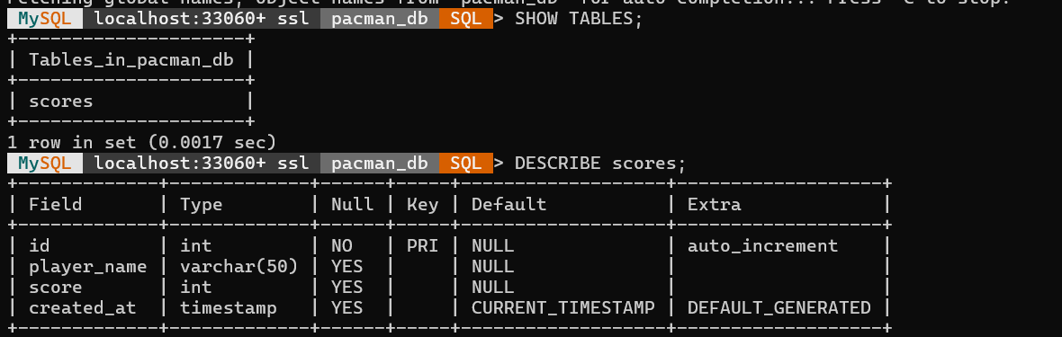

5.Output Screenshots
- Screenshot of the game running.
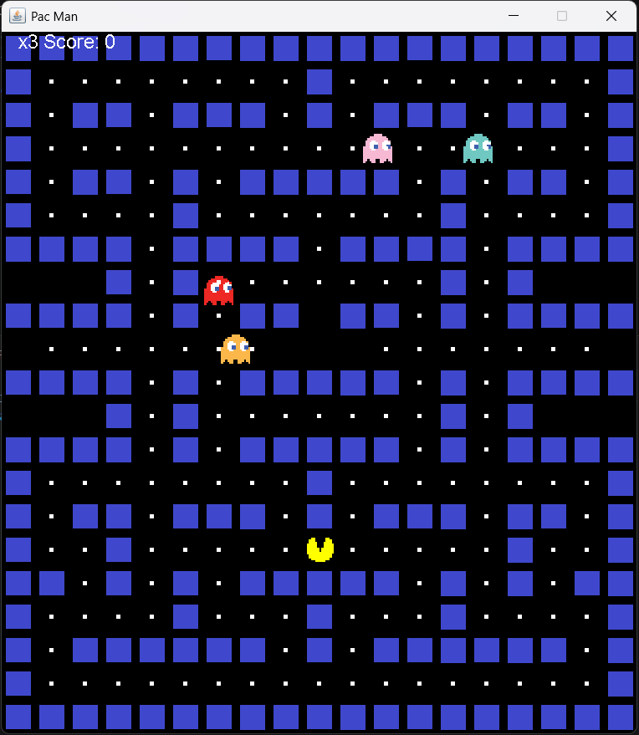
- Screenshot of the popup asking for player name.
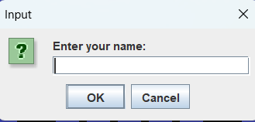

- Screenshot of MySQL table showing saved scores.
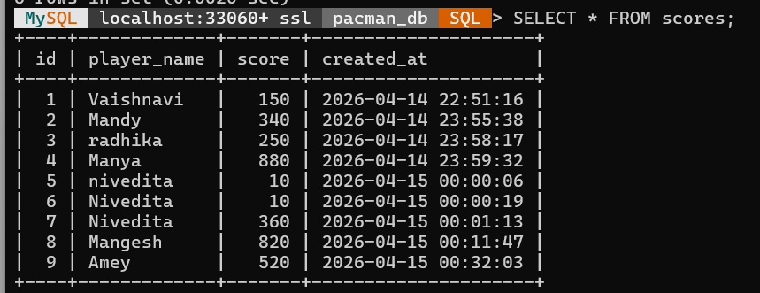
- Screenshot of MySQL table showing leaderboard (Top Scores)
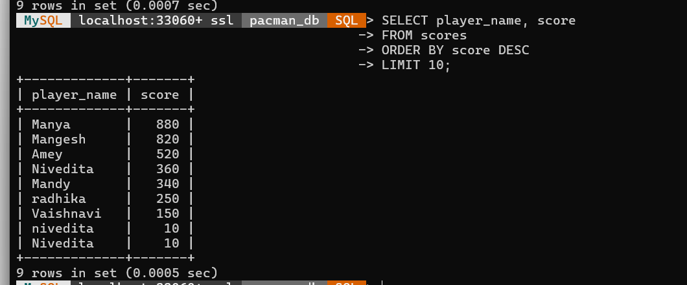
- Screenshot of MySQL table showing highest score per player
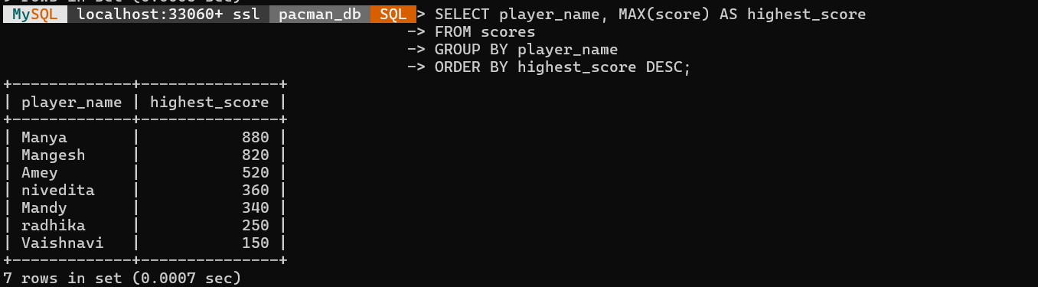
- Screenshot of MySQL table showing average score per player
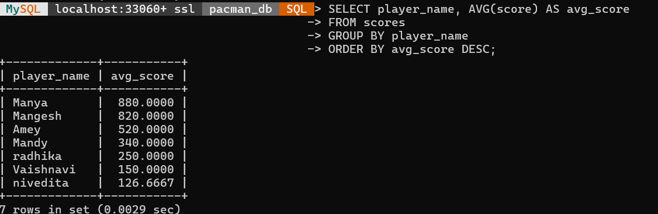
- Screenshot of MySQL table showing update a player’s name
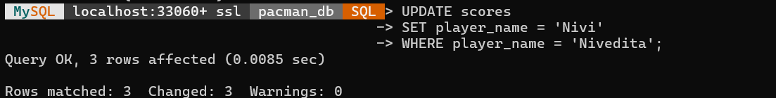
- Screenshot of MySQL table showing delete low scores
5. Conclusion
The Pac-Man project successfully combined Java Swing game development with MySQL database integration. Players can enjoy the game while their scores are automatically saved, enabling leaderboard creation and performance tracking. This demonstrates how front-end gameplay and back-end data management can work together effectively.

